**Lab Assignment-1**

**Task Description#1**● Write a comment: # Function to check if a string is a valid palindrome (ignoring  
spaces and case) and allow Copilot to complete it.  
Expected Output#1  
● A function that correctly returns True for phrases like "A man a plan a canal Panama"

Prompt:

Give a Python function code to check if a string is valid palindrome, ignoring the spaces and case  
Give a dynamic code with output also

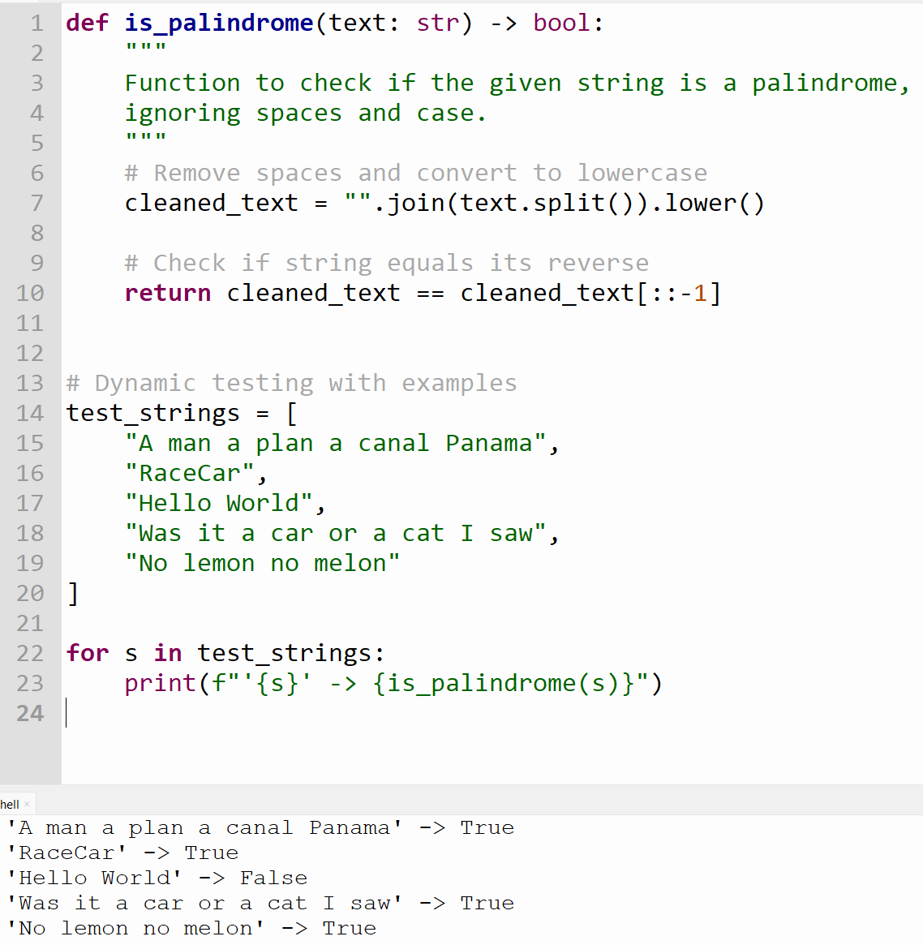

**Task Description#2**● Generate a Python function that returns the Fibonacci sequence up to n terms. Prompt  
with only a function header and docstring  
Expected Output#2  
● AI completes the function logic using loop or recursion with accurate output

Prompt:

Generate a Python function code that returns the Fibonacci sequence up to n terms with a function header and docstring Give output

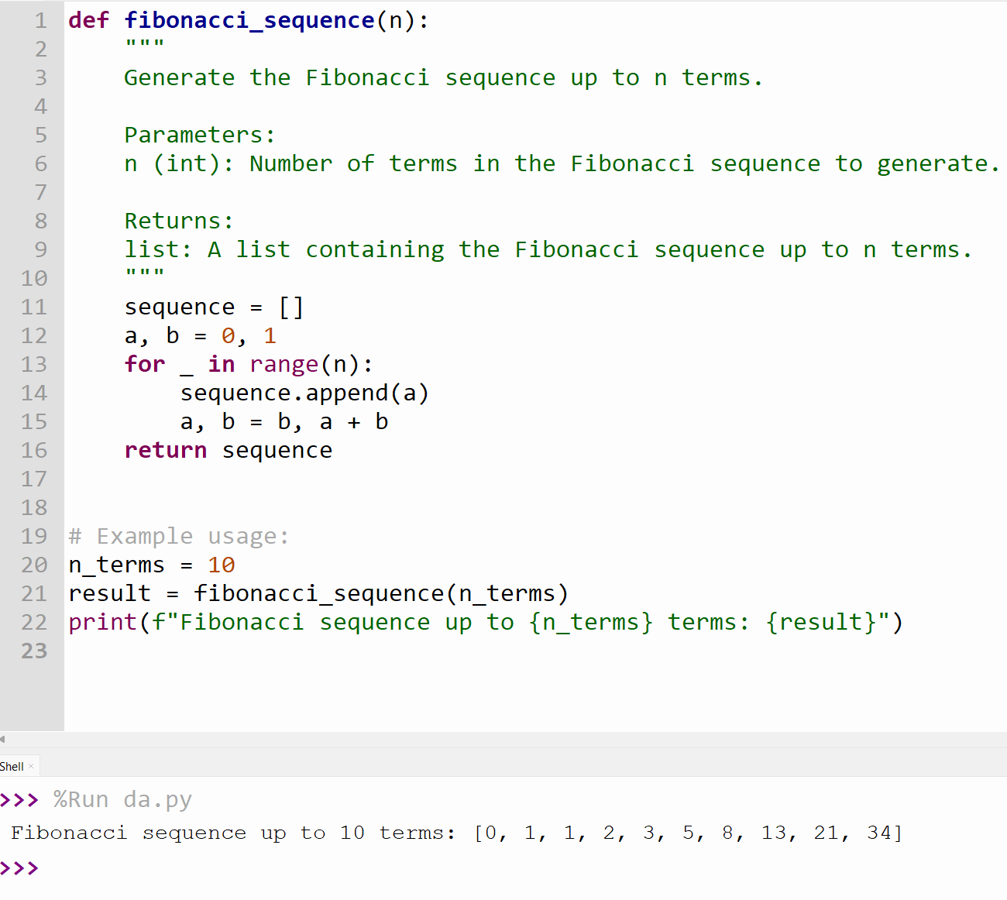

**Task Description#3**● Write a comment like # Function to reverse a string and use Copilot to generate the  
function.  
Expected Output#3  
● Auto-completed reverse function

Prompt:

Generate a python function to reverse a string.

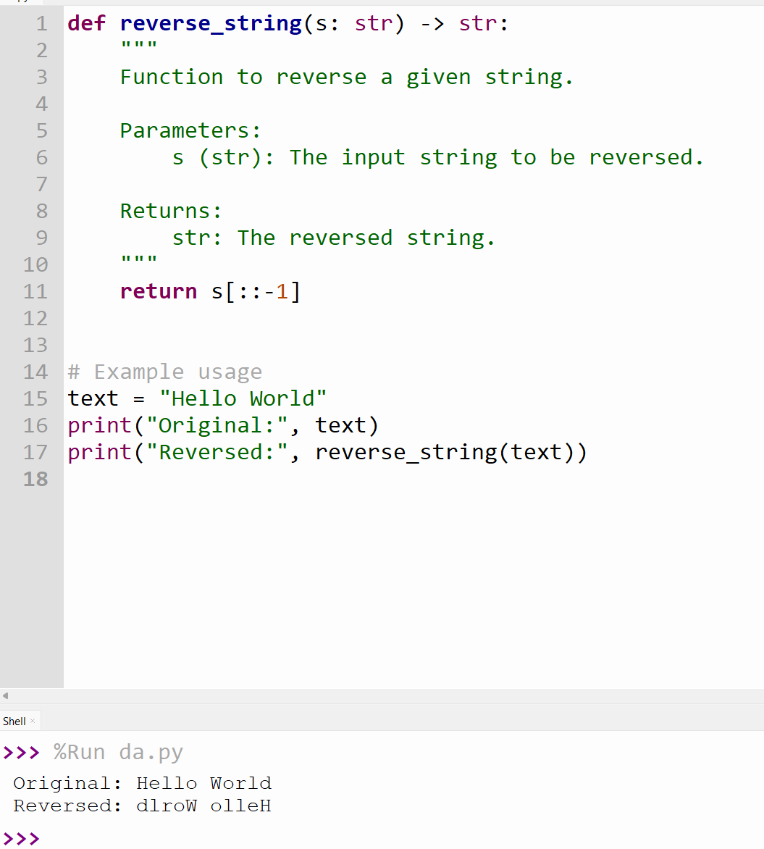

**Task Description#4**● Generate a program that simulates a basic calculator (add, subtract, multiply, divide).  
Write the comment: # Simple calculator with 4 operations and let AI complete it.  
Expected Output#4  
● Fully working calculator with input/output and operator selection logic

Prompt:

Generate a Dynamic python code for simple calculator, which has operations like

Addition

Subtraction

Multiplication

Division

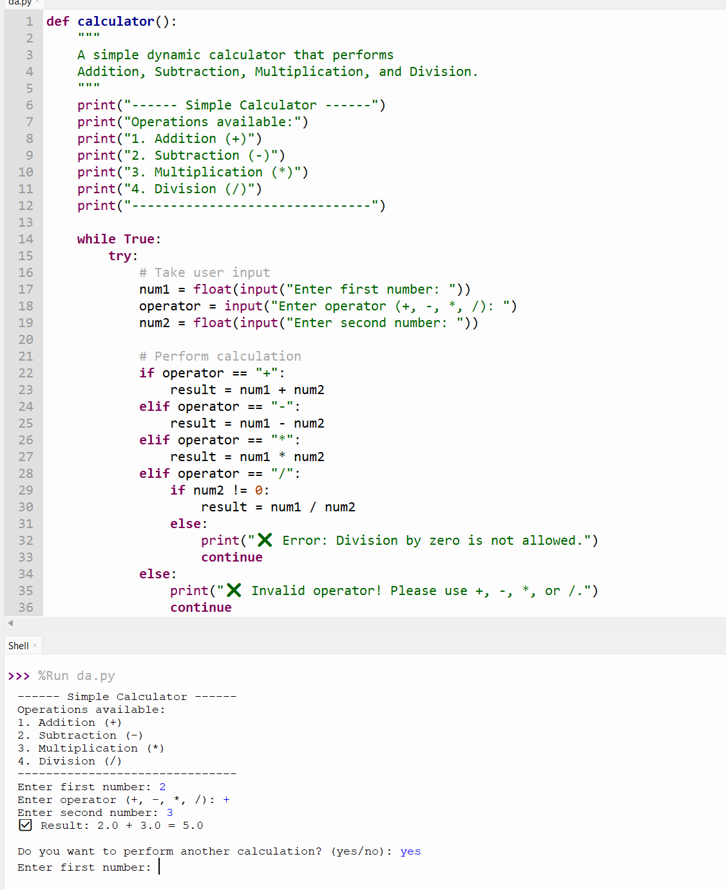

**Task Description#5**● Use a comment to instruct AI to write a function that reads a file and returns the  
number of lines..  
Expected Output#5  
● Functional implementation using open() or with open() and readlines()

Prompt:

Generate a python code that reads a file and returns the number of lines.

